KAARKUN: An AI-Powered Multi-Platform Service Marketplace

By

ZAHEER ABBAS (449 )

MUHAMMAD DAWOOD (446)

ISMAIL KHAN (488)

Thesis Submitted to University of Swabi, Khyber Pakhtunkhwa, in partial fulfillment of the requirement for the degree of

BACHELOR OF SCIENCE IN COMPUTER SCIENCE

Approved by:

Chairman Supervisory Committee
Dr. Shah Nazir

Co-Supervisor [Field/ Research/ Lab]
Prof. Hammad

Chairman Department of Computer Science
Prof. Mushtaq Ali Shah

DEPARTMENT OF COMPUTER SCIENCE THE UNIVERSITY OF SWABI
KHYBER PAKHTUNKWA, PAKISTAN
SESSION (2022-2026)

CHAPTER-I
INTRODUCTION
1.1 Project Overview / Background
The growth of the global platform economy has changed the way people find and access services, as well as how service providers find work. Digital service marketplaces such as Uber, TaskRabbit, and Urban Company have shown how online platforms can bring customers and service providers together in a more organized and efficient way. By making it easier for customers to find suitable providers, compare prices, communicate directly, and review previous experiences, these platforms can reduce the time and effort involved in finding services. At the same time, features such as ratings, identity verification, and user reviews help build trust and provide greater accountability for both customers and service providers.
In Pakistan, a large part of the skilled-trade and residential service sector still operates informally. Many plumbers, electricians, carpenters, painters, and household cleaners work without formal registration or a digital presence, making it difficult for customers to find and assess their services. In most cases, customers rely on recommendations from friends, family members, or people in their local communities to find a service provider. While this traditional approach can be useful, it also limits providers to a relatively small geographic area and makes it difficult for new workers to build a customer base. additionaly, there is often no reliable way to verify a provider’s skills or credentials, track service quality, or establish accountability when problems occur.
Khyber Pakhtunkhwa (KPK) faces this challenge more clearly due to the limited availability of digital platforms for local service providers. Although mobile internet access and smartphone use have increased across the province, there is still a lack of platforms specifically designed to connect customers with residential service providers in Khyber Pakhtunkhwa. Many existing service platforms primarily focus on larger cities such as Karachi and Lahore, while others may not fully consider the local language, culture, and economic conditions of the region. As a result, there is an opportunity to develop a dedicated digital marketplace that is designed around the needs of customers and service providers in Khyber Pakhtunkhwa.
The word Kaarkun is derived from the Urdu/Pashto word for worker is designed to fill this gap. It is a multi-platform AI-assisted service marketplace that connects customers with verified skilled service providers through a competitive bidding system, real-time communication tools, GPS-based location tracking system, and a QR Handshake code attendance verification mechanism.
1.1.2 Problem Statement
Regardless of the scale and economic significance of the informal skilled labour market in Pakistan, several structural problems remain that reduce efficiency and trust for both customers and service providers:
Discoverability gap. Customers cannot efficiently locate skilled workers in their locality, workers cannot reach new customers beyond their existing social networks.
Absence of verified credentials. No mechanism exists for customers to verify a worker's qualifications, experience, or identity before contract.
Price opacity. Service prices are set informally without reference to market rates, enabling exploitation of uninformed customers and undercutting of skilled workers.
Communication gap. Once a service is arranged, there is no structured channel for customer and provider communication, leading to missed appointments and unresolved misunderstandings.
Lack of accountability. There is no formal record of service delivery, no attendance verification mechanism, and no structured system for post service feedback.
1.1.3 Research Objectives
The following five research objectives guided the design, development, and evaluation of the Kaarkun platform:
1. Design and implement a multi-platform service marketplace connecting customers with verified skilled service providers through a integrated mobile and web interface.
2. Implement a transparent, competitive bidding system that allows multiple verified providers to bid on customer posted job requests, replacing unclear informal price negotiation.
3. Provide real-time communication tools and GPS-based location tracking system to improve service reliability and reduce information Inequality between customers and providers.
4. Integrate an AI assistant chatbot for self service platform guidance, accessible without a network connection.
5. Establish a trust mechanisms through verified identity screening, QR handshake code-based attendance verification, and a structured peer review and rating system.
1.2 Project Scope
Table 3.1 presents the defined scope boundaries and acknowledged limitations of the Kaarkun system.
Table 3.1 — Scope and Limitations of Kaarkun
Scope (Included) | Limitation (Excluded)
Flutter mobile app (Android & iOS) | iOS App Store publication (development only)
Next.js customer web application | Desktop native application
Next.js administration panel | Multi-language UI (English only)
Node.js/Express.js REST API | Real payment gateway integration
MySQL 8.0 relational database | Production-grade load testing
Real-time chat via Socket.io | Third-party push notifications (FCM)
Live GPS tracking via Google Maps | IoT hardware integration
QR code check-in/checkout | Formal user study with real users
Rule-based AI chatbot | LLM-based conversational AI
Admin panel (user & booking management) | Multi-city/multi-country deployment
1.3 Tools and Technologies
The Kaarkun platform was built using a carefully selecting set of software tools, frameworks, and hardware resources that together support the development of a production-quality, multi-platform service marketplace. The following sub-sections document the development environment, technology stack, and hardware configuration used throughout this project.
1.3.1 Software
The following software tools were used during development: Visual Studio Code (v 1.133.0) as the primary code editor for backend and web development, Android Studio Quail 1 | 2026.1.1 Patch 2 for Flutter mobile development and Android emulator management, Git (v 2.45.1) and GitHub for version control and collaborative workflows, Docker Desktop (v4.29) for local containerised testing, Postman (v10) for REST API testing and documentation, MySQL Workbench (v8.0.47) and MySQL client (mysql2: 3.20.0) for database schema design and query execution, and the AWS Management Console for cloud resource monitoring and ECS service management.
1.3.2 Tech Stack
The Kaarkun technology stack has four tiers:
(i) Client side: Flutter 3.38.3 (Dart: 3.10.1) for the cross-platform mobile application; Next.js 16.2.9 with TypeScript for both the customer web frontend and the administration panel.
(ii) Server side: Node.js 20-alpine with Express.js(5.2.1) for the REST API; Socket.IO 4 for real-time WebSocket communication, and Multer-S3 for file uploads to Amazon S3.
(iii) Data side: MySQL 8.3 via the mysql2 driver for relational data; Amazon S3 for binary asset storage (avatars, job images, chat attachments).
(iv) Infrastructure side: Amazon Web Services (ECS Fargate, RDS, ALB, S3, ECR, Secrets Manager, CloudWatch, IAM); HashiCorp Terraform 1.8 for Infrastructure-as-Code; and GitHub Actions for CI/CD pipeline automation.
1.3.3 Hardware
Development was carried out on a Windows 11 Pro laptop equipped with an Intel Core i5 processor, 16 GB RAM, and a 512 GB SSD. The mobile application was tested on an Android Virtual Device (API level 33) and on a physical Android 13 smartphone. Production deployment runs on AWS Fargate in the ap-south-1 (Mumbai) region; each ECS task is allocated 0.5 vCPU and 1 GB memory. The production database is hosted on an Amazon RDS db.t3.micro instance with 20 GB General Purpose SSD storage.
1.4 Limitations of Kaarkun
Despite the breadth of features implemented, the Kaarkun platform has the following limitations within the scope of this Final Year Project:
- The mobile application was developed and tested for Android only, iOS App Store and Google playstore publication requires a paid Apple Developer account and paid playstore console account that is outside the project budget.
- The wallet module does not integrate a live third-party payment gateway, top-up and withdrawal flows are implemented at the application level, but final settlement with JazzCash or EasyPaisa is deferred to a future release.
- The system has not undergone production-grade load testing or formal security penetration testing.
- Although the system was designed to support service seekers and providers in Khyber Pakhtunkhwa, no formal user study was conducted with real users from the region. Therefore, the system’s usability, acceptance, and effectiveness across different areas of Khyber Pakhtunkhwa have not been empirically validated.
1.5 Outline of Thesis
The remainder of this thesis is organised as follows. Chapter II presents a review of the relevant literature on the platform economy, digital service marketplaces in South Asia, and an analysis of the research gap that Kaarkun addresses. Chapter III describes the research methodology, system architecture, requirements, use case analysis, database design, implementation features, and security design. Chapter IV presents the results of functional and integration testing and discusses findings in relation to the research objectives. Chapter V provides a comprehensive summary. Chapter VI presents conclusions and seven recommendations for future development. The Literature Cited section and Short Biography follow.

CHAPTER-II
REVIEW OF LITERATURE
2.1 The Platform Economy Overview
Research on multi-sided platforms has grown significantly over the past two decades. Rochet and Tirole (2003) established the economic foundation of two-sided markets by explaining how platforms connect two or more distinct user groups and reduce the costs involved in finding and dealing with one another. Parker, Van Alstyne, and Choudary (2016) further explained that digital platforms create value by enabling interactions between producers and consumers. Evans and Schmalensee (2016) also highlighted how digital matchmaking platforms reduce search difficulties and information gaps between parties who may otherwise struggle to connect efficiently.
Hagiu and Wright (2015) distinguished multi-sided platforms, which allow different user groups to interact directly, from resellers that purchase and sell services themselves. This distinction applies to Kaarkun because customers and service providers communicate directly, while the platform provides the infrastructure, communication tools, and trust mechanisms that support their interaction. De Reuver, Sorensen, and Basole (2018) identified trust and governance as major challenges for digital platforms. Kaarkun addresses these concerns through features such as provider identity verification and QR-based attendance verification, which aim to improve accountability and create a safer environment for both customers and service providers.
2.2 Digital Service Platforms in South Asia
The growth of on-demand service platforms in South Asia has been strongly influenced by Urban Company, formerly known as UrbanClap. The platform operates in India and the UAE and connects customers with home-service professionals such as plumbers, electricians, and beauticians. Before joining the platform, service providers generally go through identity verification, background checks, and skills assessments. Unlike Kaarkun, Urban Company mainly relies on algorithm-based matching rather than allowing customers to compare competing bids. Malik and Khan (2020) identified trust and the onboarding of informal workers as two major challenges for platform adoption in South Asian cities, where many service providers work outside formal employment structures.
Choudary (2015) explained that service marketplaces benefit from network effects. As more verified providers join, customers gain access to a wider range of services. At the same time, a growing customer base creates more employment opportunities for providers. This relationship is particularly important in Khyber Pakhtunkhwa, where people often depend on personal recommendations and word-of-mouth referrals when hiring local service providers. Kaarkun aims to complement these existing practices by offering a more organized platform with provider verification, service discovery, and direct communication between customers and providers.
2.3 Pakistan Digital Economy and Khyber Pakhtunkhwa Context
Pakistan’s digital economy has expanded considerably since 2018, largely because of the wider availability of 4G mobile networks and government efforts to promote digital services. Rahman and Ali (2019) identified several barriers affecting e-commerce adoption in Pakistan, including a lack of trust, limited digital payment options, and weaknesses in last-mile delivery. These challenges are particularly relevant to service platforms, where users need confidence in both the service provider and the transaction process.
Ahmed, Rehman, and Shah (2021) examined mobile commerce adoption in Khyber Pakhtunkhwa and reported that smartphone usage in the province’s urban areas had exceeded 60% by 2021. However, they also noted the lack of locally relevant applications offering Urdu or Pashto language support and culturally appropriate interfaces. Ahmad and Hussain (2022) further found that digital labour platforms could improve the incomes of informal workers by helping them reach a larger customer base. These findings support the need for platforms such as Kaarkun, which are designed around local users, service needs, and working conditions.
2.4 Mobile and Web Technologies for Service Marketplaces
The technical implementation of service marketplaces has joined on cross-platform mobile development frameworks and JavaScript-based web stacks. Flutter, Google's UI toolkit for building natively compiled applications from a single Dart codebase, has emerged as the leading framework for cross-platform mobile marketplace development. Farhan and Baig (2020) compared Flutter and React Native for service marketplace implementations, concluding that Flutter's performance characteristics and widget system made it preferable for applications requiring real-time map rendering and complex UI state management. The combination of Node.js with Socket.io for real-time WebSocket communication has become standard for in-app messaging and live location tracking features in service marketplace applications.
2.5 Comparative Analysis of Existing Platforms
Table 3.2 presents a structured comparison of Kaarkun with three relevant service marketplace platforms: Urban Company, TaskRabbit, and Rozgar.pk. The comparison highlights differences in platform availability, communication, verification, bidding, tracking, and AI-supported services. Based on the selected features, Kaarkun combines several functions that are not commonly available together on the compared platforms, particularly competitive bidding, QR-based attendance verification, real-time GPS tracking, and AI-assisted support.
Table 3.2 — Comparative Analysis of Service Marketplace Platforms
Feature | Kaarkun  (This Study) | Urban Company  (India) | TaskRabbit  (USA) | Rozgar.pk  (Pakistan)
Mobile Application | Yes (Flutter) | Yes | Yes | No
Web Application | Yes (Next.js) | Yes | Yes | Yes
Competitive Bidding | Yes | No | No | No
QR Attendance Verification | Yes | No | No | No
Real-Time GPS Tracking | Yes | No | No | No
In-App Chat | Yes | Yes | Yes | No
AI Chatbot | Yes | No | No | No
Identity Verification | Yes | Yes | Yes | Partial
Available in Pakistan | Yes | No | No | Yes
2.6 Research Gap
The comparative analysis in Table 2.1 reveals that no existing platform serving the Pakistani residential service market combines the full feature set of real-time chat, live GPS tracking, QR code verification, competitive bidding, an AI chatbot, and a dedicated admin panel within a single mobile-plus-web architecture. Urban Company provides the closest functional match globally, but it operates exclusively in India, is not adapted for the Pakistani market, and does not offer QR-based booking verification. Rozgar.pk addresses the Pakistani labour market context but lacks a mobile application, real-time communication features, GPS tracking, and structured competitive bidding. Kaarkun therefore fills a genuine and unaddressed gap by delivering all of these features within a platform explicitly designed and tested for the Pakistani residential service context, targeting the specific conditions of Khyber Pakhtunkhwa.

CHAPTER-III
MATERIALS AND METHODS
3.1 Research Methodology (DSR)
This project follows the Design Science Research (DSR) methodology proposed by Hevner, March, Park, and Ram (2004). In DSR, the developed artefact is both the main research outcome and the means of addressing the identified problem. For this study, The developed system is the Kaarkun platform. The project was guided by the DSR process model developed by Peffers, Tuunanen, Rothenberger, and Chatterjee (2007), which consists of six phases: problem identification and motivation, definition of solution objectives, design and development, demonstration, evaluation, and communication. Within this structure, two-week Agile development sprints were used to implement, review and improve the platform features throughout the development process.
Initial requirements were collected through a review of comparable service marketplace platforms and informal exploratory interviews with five residential service workers and eight household customers from Swabi district. These discussions helped confirm the main problems identified in Section 1.2 and contributed to the definition of the twenty functional requirements presented in Section 3.3. However, these interviews should not be described as a formal user study; they were used only for preliminary requirements gathering and informal validation.
3.2 System Architecture Diagram
Kaarkun employs a three-tier client-server architecture comprising a Client Layer, a Server Layer, and a Data Layer, supported by external service integrations. The Client Layer consists of three independently deployable front-end applications: the Flutter mobile application, the Next.js web application, and the Next.js administration panel. All three clients communicate with the Server Layer exclusively through HTTPS REST API endpoints and authenticated Socket.io WebSocket connections. The Server Layer, implemented on Node.js with Express.js, encapsulates all business logic. The Data Layer consists of a MySQL 8.0 database accessed through the mysql2 prepared-statement driver. Figure 1.1 presents the complete system architecture.

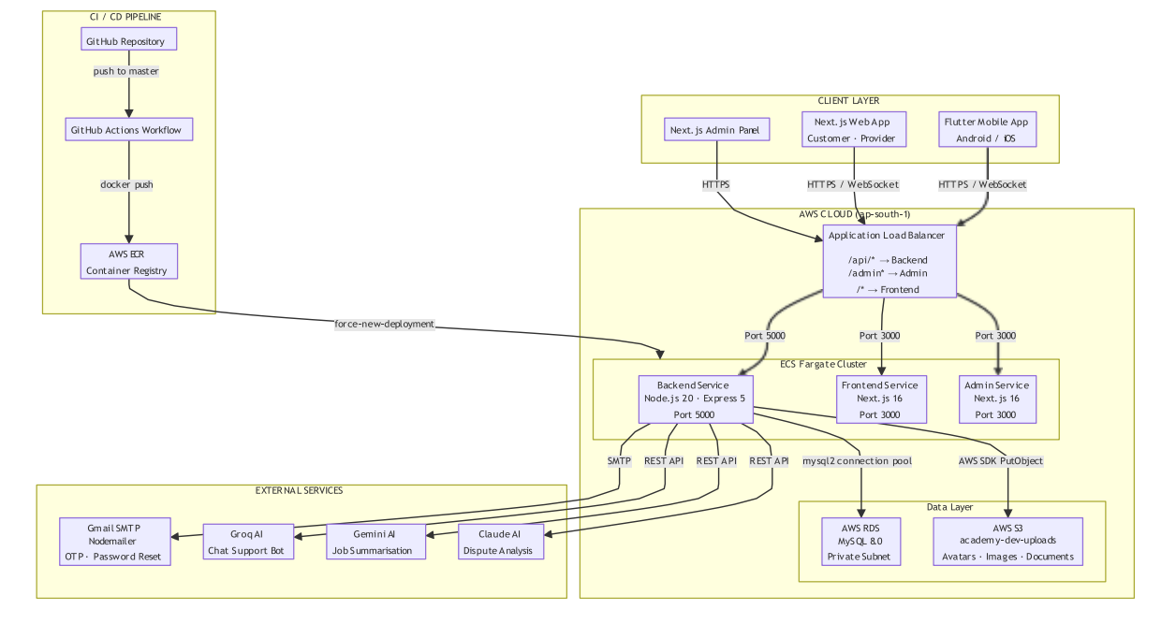

Figure 1.1 — Kaarkun System Architecture Diagram
3.3 Functional Requirements
The system requirements were organised into eight functional areas: authentication, job management, bidding, booking, communication, GPS tracking, reviews, notifications, and administration. Twenty functional requirements were defined and prioritised as High or Medium based on their importance to the core operation of the Kaarkun platform.
Table 3.3 — Kaarkun Functional Requirements
ID | Module | Requirement Description | Priority
FR-01 | Authentication | System shall allow customers/providers to register with name, email, phone, password, and role. | H
FR-02 | Authentication | System shall authenticate users with email and password, returning a signed JWT valid for 24 hours. | H
FR-03 | Authentication | Service providers shall submit identity documents for admin review before appearing publicly. | H
FR-04 | Job Management | Customers shall post a job request specifying title, description, category, date, and GPS location. | H
FR-05 | Job Management | System shall display open jobs to providers filtered by category and sorted by proximity. | H
FR-06 | Job Management | Customers shall view the status of all posted jobs: open, booked, completed, or cancelled. | M
FR-07 | Bidding | Service providers shall submit a bid specifying a quoted price and explanatory message. | H
FR-08 | Bidding | Customers shall view all bids and accept exactly one, transitioning the job to booked status. | H
FR-09 | Booking | Upon bid acceptance, system shall auto-generate a unique QR code delivered to the customer. | H
FR-10 | Booking | Provider shall scan the customer QR code on arrival (check-in) and again on completion (check-out). | H
FR-11 | Booking | System shall record timestamped check-in and check-out events visible to both parties. | M
FR-12 | Communication | System shall provide real-time in-app messaging via Socket.io between customer and provider. | H
FR-13 | Communication | Mobile app shall provide a rule-based AI chatbot accessible from the home screen. | M
FR-14 | GPS Tracking | Customer shall view provider real-time GPS location on a map after booking confirmation. | H
FR-15 | GPS Tracking | Provider app shall broadcast GPS coordinates via Socket.io at configurable intervals. | H
FR-16 | Reviews | After service completion, customer shall submit a star rating (1-5) and optional review. | H
FR-17 | Reviews | Provider public profile shall display average rating and five most recent written reviews. | M
FR-18 | Notifications | System shall create in-app notifications for: new bid, bid accepted, booking confirmed, service started, completed. | H
FR-19 | Admin | Admin panel shall allow administrators to view, search, activate, or deactivate any user account. | H
FR-20 | Admin | Admin panel shall display a dashboard of platform totals: users, providers, bookings, and open reports. | M
3.4 Use Case Analysis
Figure 1.2 and Figure 1.3 document the primary interactions of the Customer and Service Provider actors with the Kaarkun system respectively. The Administrator actor interacts exclusively through the Next.js admin panel to manage user accounts, approve provider credentials, monitor platform activity, and resolve reports.

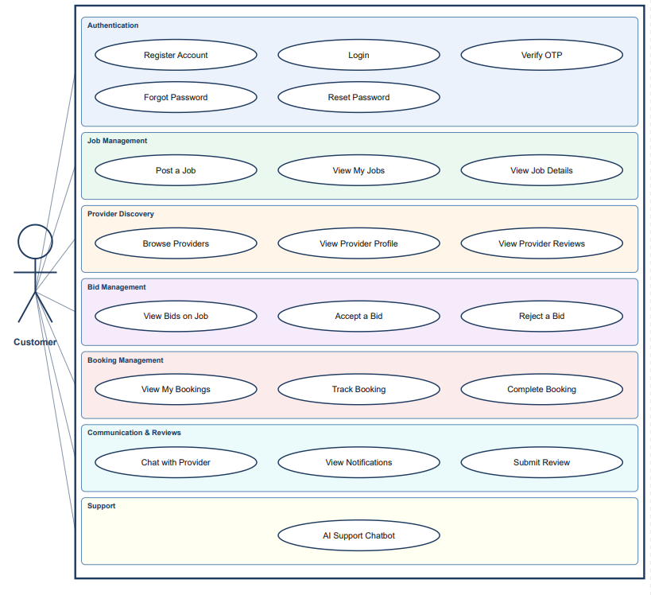

Figure 1.2 — Use Case Diagram: Customer Actor

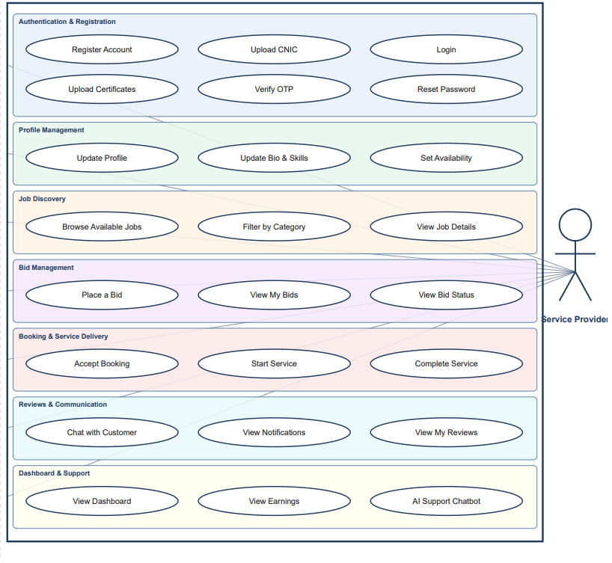

Figure 1.3 — Use Case Diagram: Service Provider Actor
3.5 Database Design (ERD Diagram)
The Kaarkun database is implemented in MySQL 8.0 and comprises eleven relational tables in Third Normal Form (3NF) to eliminate redundancy and enforce referential integrity through foreign key constraints. The central entity is users, which stores both customer and service provider accounts distinguished by a role column. The provider profiles table extends the users record for provider specific attributes. Jobs may receive multiple bids, one accepted bid creates a bookings record containing the auto-generated QR handshake code string and check-in/checkout timestamps. Post completion reviews are linked to bookings. Real-time messages are persisted for chat history. The notifications table supports platform governance. Figure 1.4 presents the complete Entity-Relationship Diagram.

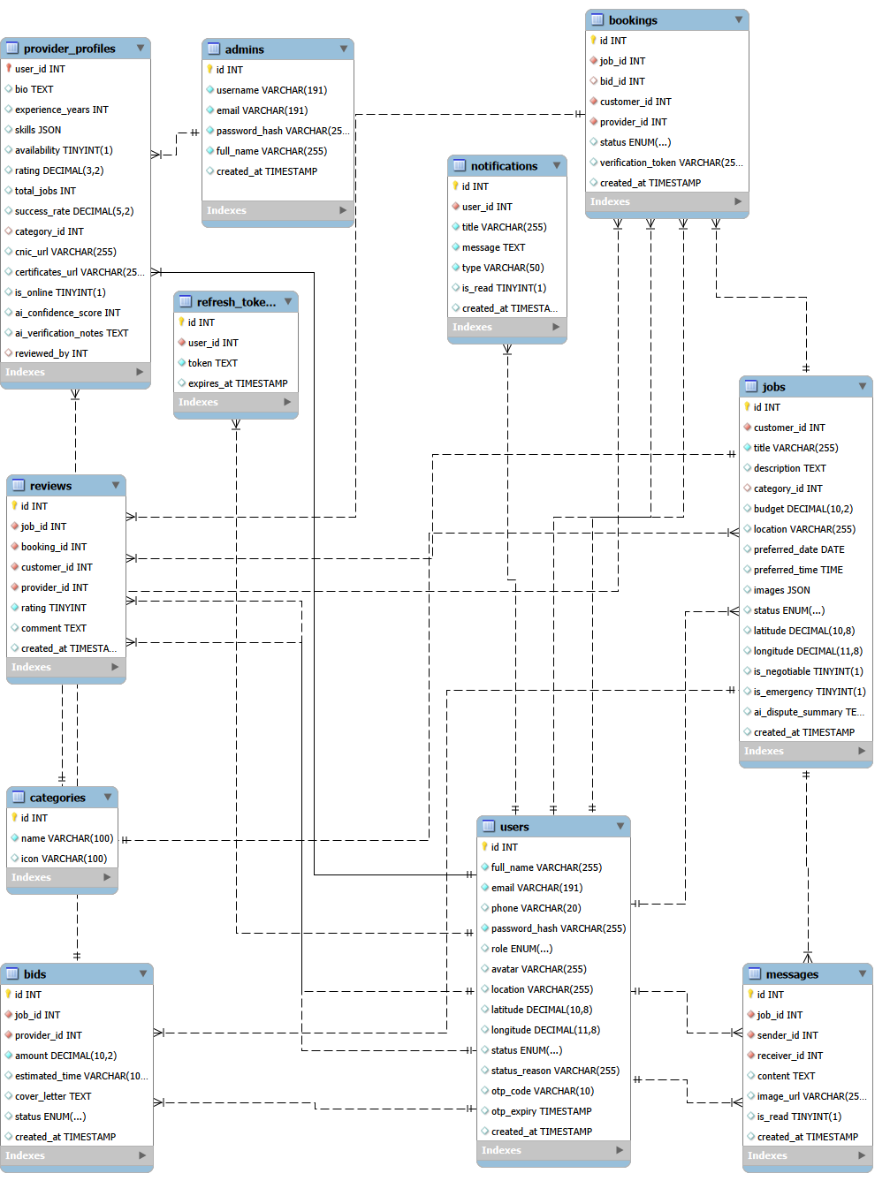
Figure 1.4 — Entity-Relationship Diagram: Kaarkun Database (11 Tables)
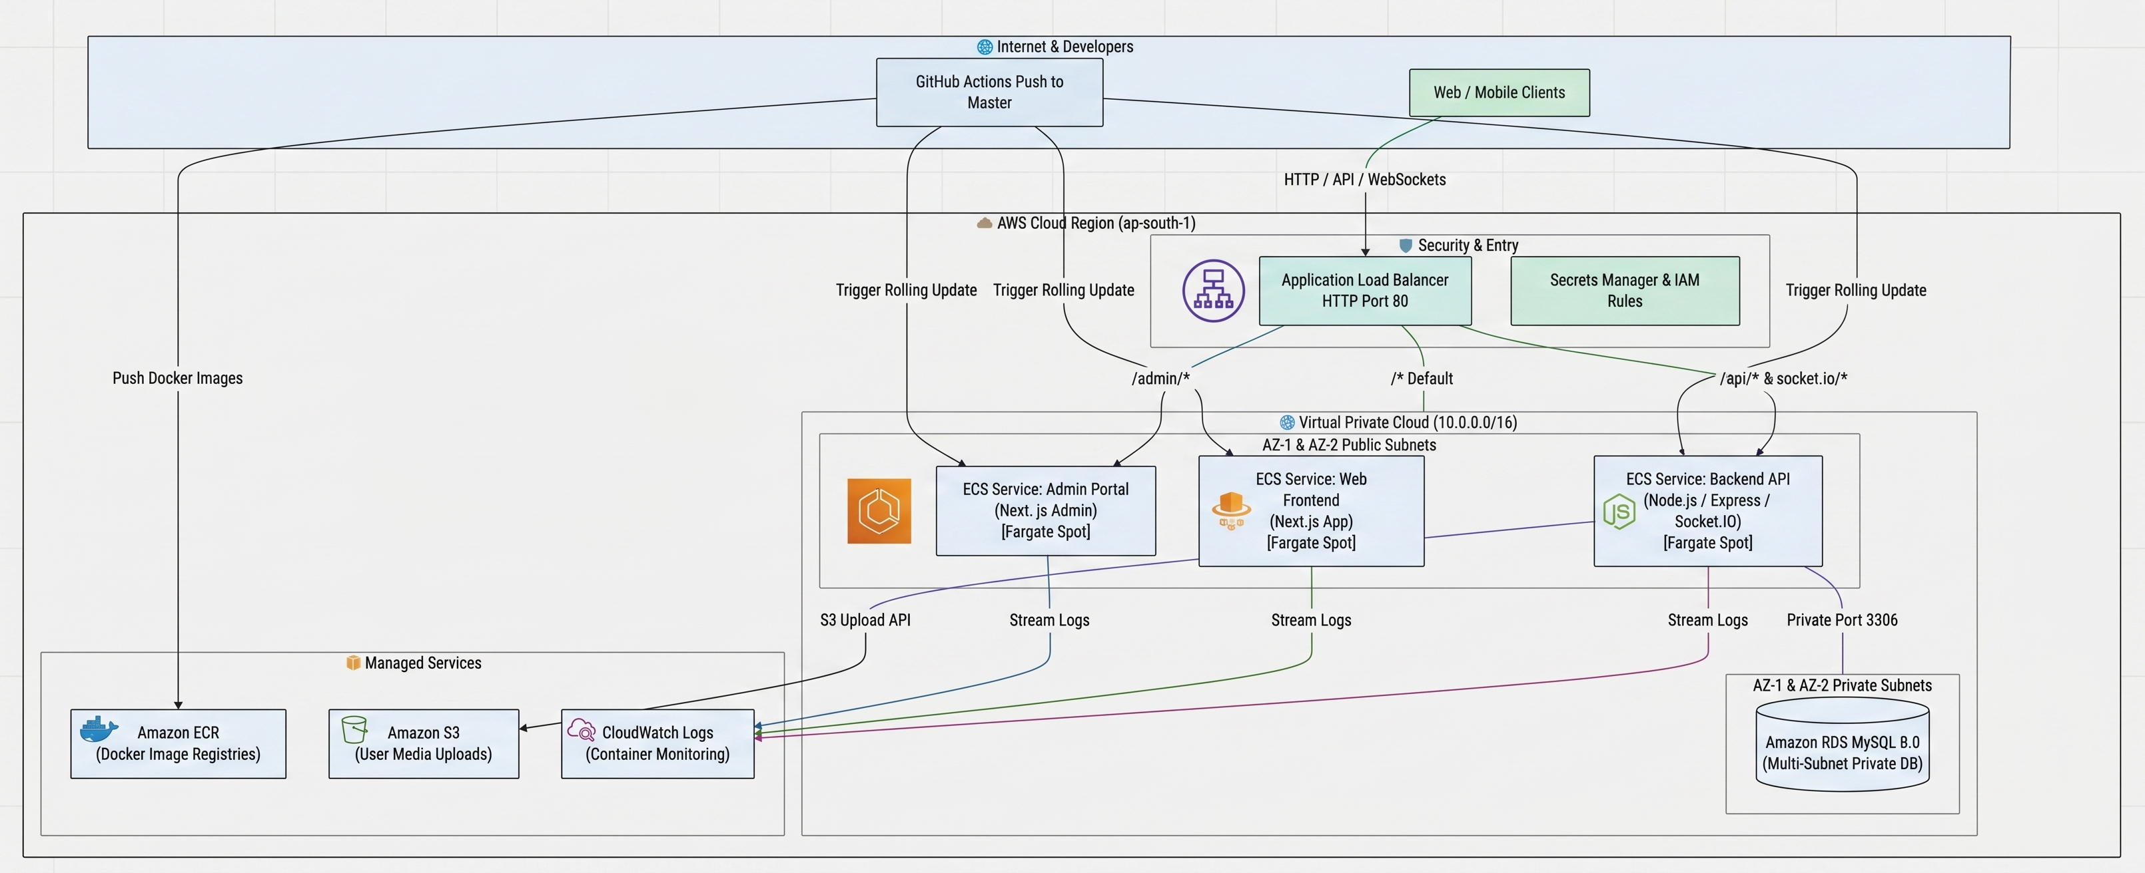
Figure 1.5 — Cloud Infrastructure

3.6 Implementation Features
3.6.1 Authentication and Authorization
User registration is processed by a POST /api/auth/register endpoint that validates inputs, hashes passwords using bcrypt (salt factor 10), and creates the user record. Login via POST /api/auth/login verifies the password hash and returns a signed JWT encoded with the user's ID, role and email, set to expire after 24 hours. All protected API routes validate the JWT through Express middleware. Service provider registration additionally requires document upload pending administrator approval. Only verified providers appear in the public job feed.
3.6.2 Job Posting, Bidding and Booking
Customers create job requests specifying title, description, category ID, preferred date, and GPS coordinates captured through the Flutter geolocator package. Verified providers retrieve open jobs through GET /api/jobs, filtered by category and proximity. Providers submit bids via POST /api/bids. Customers accept one bid via PATCH /api/bids/:id/accept, which atomically marks the bid as accepted, rejects remaining bids, updates the job status to booked, and triggers QR code generation.
3.6.3 QR Code Verification
When the bid accept, the server generates a unique booking token via Node.js crypto.randomUUID() and encodes it as a QR image using the qrcode npm package. While on the arrival, the provider scans the customer's QR code and sends the decoded token to POST /api/bookings/:id/checkin, which validates the token and records a timestamped check-in event. An identical scan at completion triggers POST /api/bookings/:id/checkout, recording the checkout timestamp, transitioning the booking to completed, and unlocking the customer's review submission interface.
3.6.4 Real-Time Messaging and GPS Tracking
In-app chat uses Socket.io rooms keyed by booking ID. Both parties join the room on booking confirmation emitted messages are persisted to the messages table and broadcast to the other party. GPS tracking is activated upon check-in the provider Flutter app emits location_update Socket.io events every fifteen seconds;, the server relays each event exclusively to the associated customer, whose Flutter screen updates a Google Maps marker in real time.
3.6.5 AI Chatbot
The Kaarkun chatbot is implemented as an on-device, rule-based keyword-matching engine within the Flutter application. An intent library maps normalised user input to predefined response categories covering common platform queries. The highest-confidence keyword match returns a scripted response unmatched input triggers a graceful fallback. No network connection is required responses are instantaneous.
3.6.6 Administration Panel
The Next.js admin panel provides authenticated administrator access to four management modules: User Management, Document Verification (review provider uploads, approve or reject credentials), Booking Monitor, and Dashboard (real-time platform totals). All admin API routes require a JWT with role = admin validated by dedicated server middleware.

3.6.7 Wallet and Transaction System
Kaarkun integrates a platform-managed digital wallet that enables customers to maintain a pre-funded balance for paying service providers and allows providers to receive earnings automatically upon booking completion. The wallet system is implemented across both the Flutter mobile application and the Next.js web frontend, supported by a dedicated set of REST API endpoints on the Node.js backend.
The wallet data model tracks two distinct balances for each user: the available balance, representing funds that are freely withdrawable, and the escrow balance, representing funds temporarily locked against an active booking. When a customer accepts a provider's bid, the agreed amount is moved into escrow. On booking completion, the escrow balance is released to the provider's available balance, creating a tamper-evident payment trail that is linked to the same booking record used by the QR attendance mechanism.
The following wallet operations are available through the platform.
Customer top-up: Customers may add funds to their wallet in amounts between PKR 100 and PKR 50,000 per transaction. The top-up modal presents four quick-select presets (PKR 500, 1,000, 2,000, 5,000) alongside a free-entry amount field. The operation calls POST /api/wallet/topup and returns the updated balance.
Withdrawal: Both customers and providers may withdraw available-balance funds via three payment methods: Bank Transfer, JazzCash, and EasyPaisa. A minimum withdrawal of PKR 500 is enforced server-side. The operation calls POST /api/wallet/withdraw with the requested amount and chosen method, and returns the new balance. Withdrawal requests are submitted to the respective payment channel final settlement occurs according to the channel's processing timeline.
Provider earnings: Service provider wallets are credited automatically when a booking transitions to completed status. Providers do not deposit funds; they only withdraw accumulated earnings. Accordingly, the top-up control is conditionally hidden in the provider-facing wallet interface, preventing an inapplicable workflow from appearing.
Transaction history: All wallet events top-ups, withdrawals, payments, refunds, and earnings are persisted as timestamped transaction records classified by type (credit or debit) and sub-type (topup, withdrawal, payment, refund, earning). The transaction list is paginated (10 records per page) and is retrievable via GET /api/wallet/transactions?limit=10&offset=N. Each record stores the balance after the transaction, enabling a complete audit trail.
The wallet UI presents the available balance and escrow balance prominently on a gradient balance card. An information strip displaying the escrow amount appears conditionally only when funds are actively locked, avoiding unnecessary visual noise during periods with no active bookings. Toast notifications confirm successful operations and surface error messages without navigating away from the wallet screen.

3.6.8 Multilingual and Multi-Currency Interface
To address the multilingual character of the Kaarkun target market in Khyber Pakhtunkhwa where users may prefer either English or Urdu as their primary language the Flutter mobile application implements a complete internationalisation (i18n) framework using a custom LanguageProvider built on the Flutter ChangeNotifier pattern.
All user-visible strings in the Flutter application are managed through a centralised translation map defined in core/l10n/translations.dart. Two complete translation maps are maintained: enTranslations for English and urTranslations for Urdu. Each map is structured as a nested Dart Map using dot-notation keys (for example, 'wallet.topUpTitle', 'auth.login.title'). The LanguageProvider.t(key) method resolves a dot-separated path through the active translation map and returns the corresponding string, or falls back to the key itself if the path is not found, preventing null reference errors from missing translations.
The user's language preference is persisted in device storage using the SharedPreferences package under the key kaarkun_lang. This ensures that the selected language is restored across app restarts without requiring the user to re-select it on each launch. The LanguageProvider is registered as a top-level ChangeNotifier provider, making the current language reactive across the entire widget tree. Language switching takes effect immediately on the currently displayed screen without requiring navigation or an app restart.
The platform also implements a multi-currency display system through a companion CurrencyProvider. All monetary values are stored in Pakistani Rupees (PKR) in the database. The CurrencyProvider converts PKR amounts to the user's selected display currency at query time using fixed exchange-rate constants. Six currencies are supported: PKR (₨), USD ($), AED (د.إ), SAR (﷼), EUR (€), and GBP (£). Conversion rates are defined as PKR units per foreign currency unit (for example, USD: 278.0, GBP: 352.0). Converted amounts are formatted with the currency code prefix (e.g. USD 18.01) for foreign currencies, or as whole PKR integers (e.g. ₨ 5,000) for the base currency.
The user's currency selection is persisted in SharedPreferences under the key selected_currency and restored on app start via CurrencyProvider.loadCurrency(). The Settings screen exposes both the language selector (English / Urdu dropdown) and the currency selector (six-currency dropdown) within the same preferences panel, allowing users to configure both in a single location. Changes to either setting propagate instantly to all screens through the ChangeNotifier listener pattern.
The web frontend implements a parallel language context through a useLanguage() React hook that exposes at(key) translation function, ensuring that the customer and provider web interfaces display localised text consistently with the mobile application.
3.7 Project Screenshots
The following images present screenshots of the deployed Kaarkun mobile application and administration panel, illustrating the implemented user interface across the key user flows.

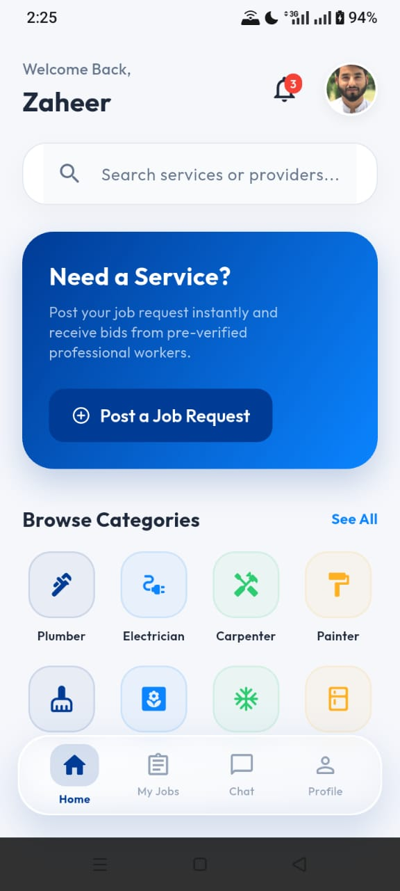
Image 2.1 Kaarkun App: Customer Home Screen

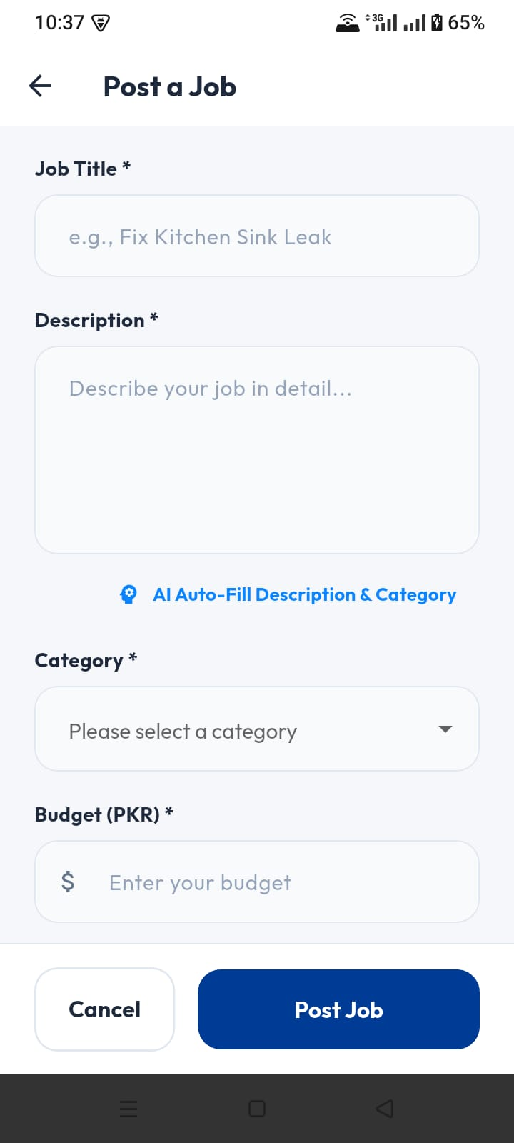

Image 2.2 Kaarkun App: Post a Job Screen
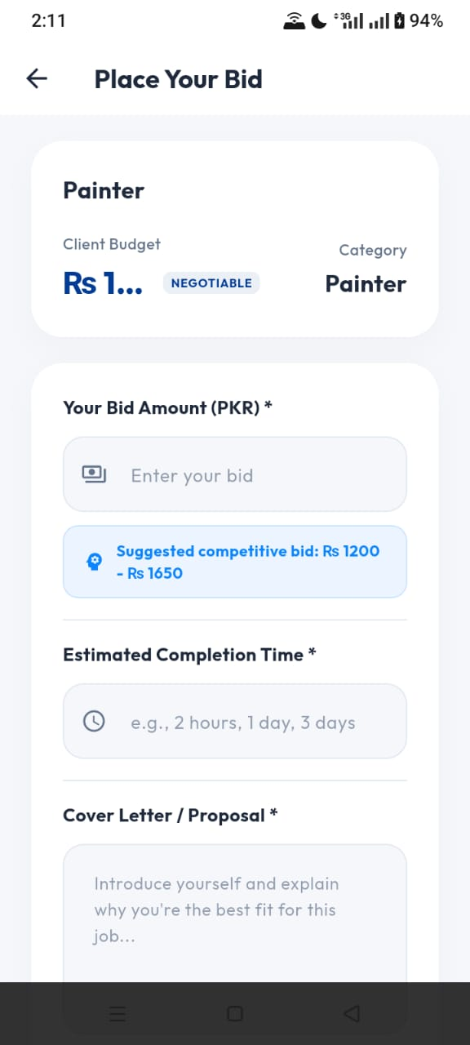
Image 2.3 Kaarkun App: Provider Bid Screen

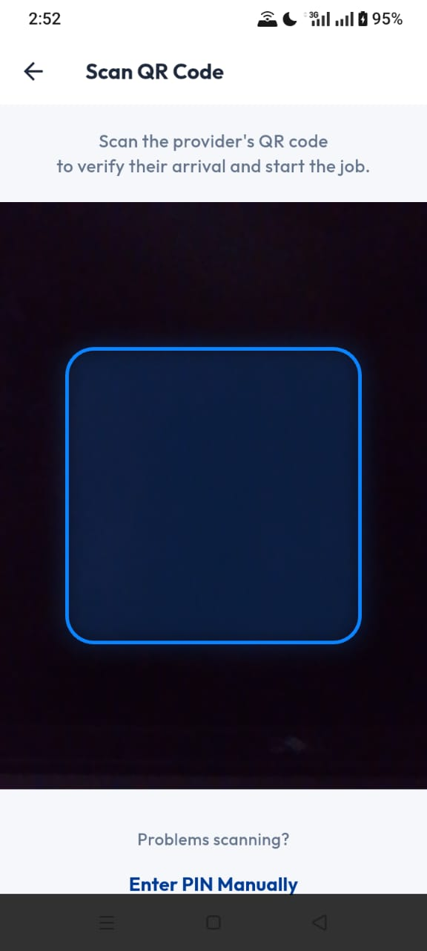
Image 2.4 Kaarkun App: QR Code Verificatoin Screen
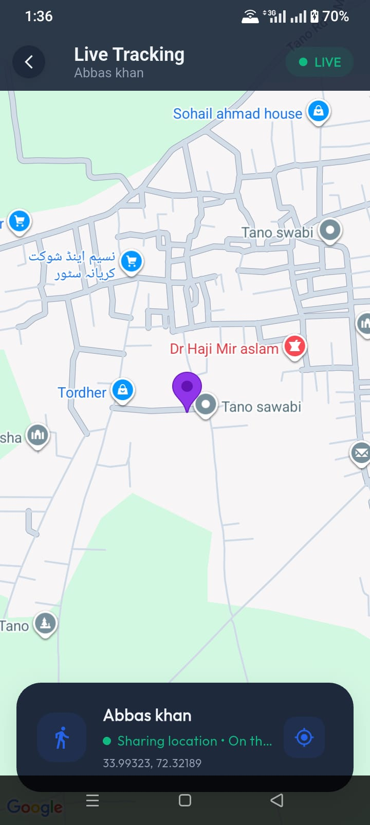
Image 2.5 Kaarkun App: Real-Time GPS Tracking Screen
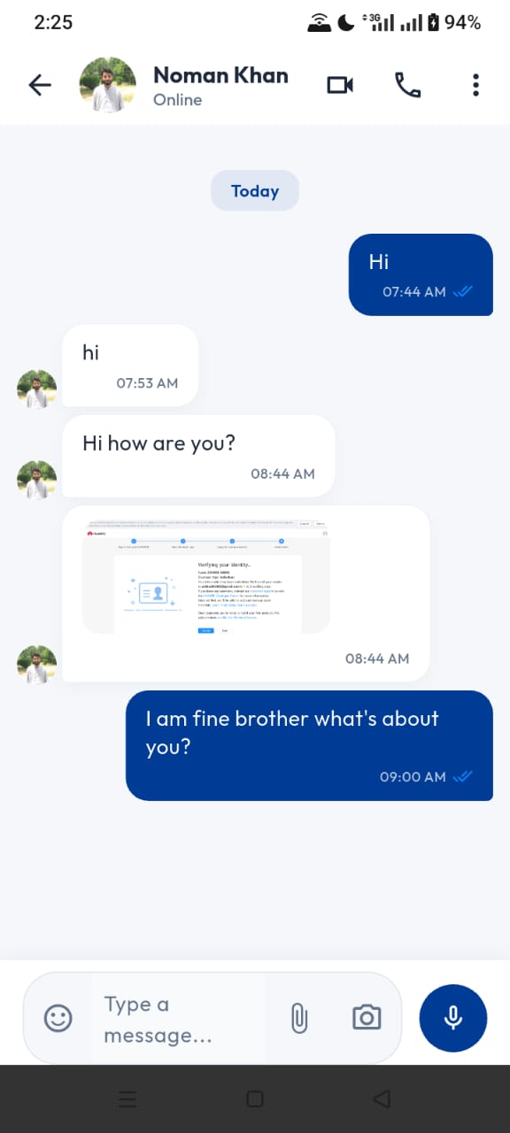
Image 2.6 Kaarkun App : In-App Chat Screen
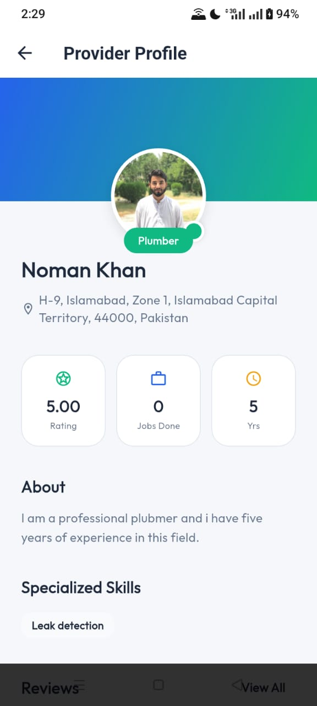
Image 2.7 Kaarkun App : Provider Profile Screen

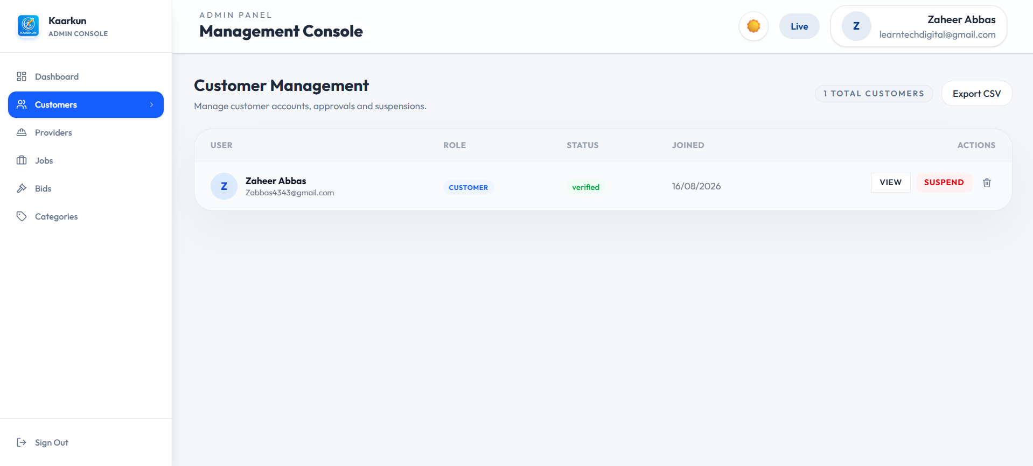

Image 2.8 Kaarkun Admin Panel : User Management

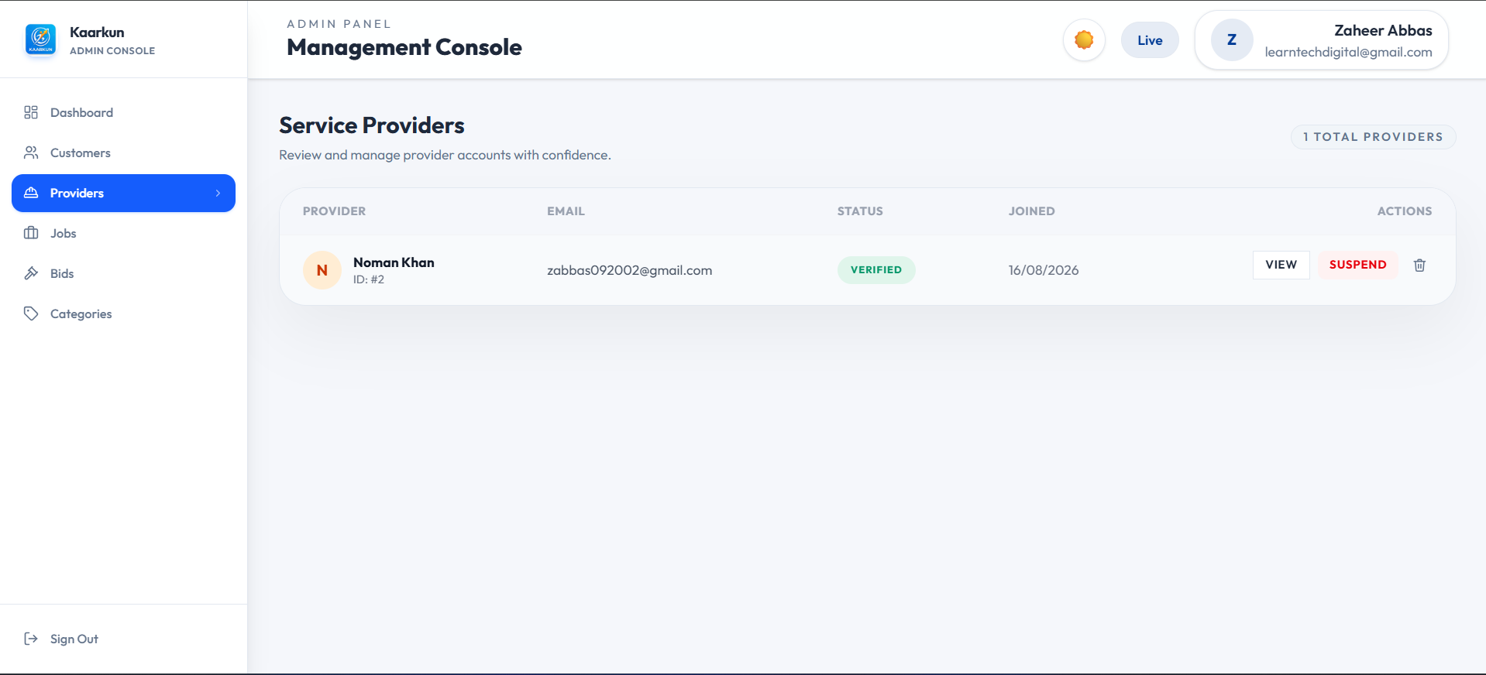

Image 2.9 Kaarkun Admin Panel : Provider Verification
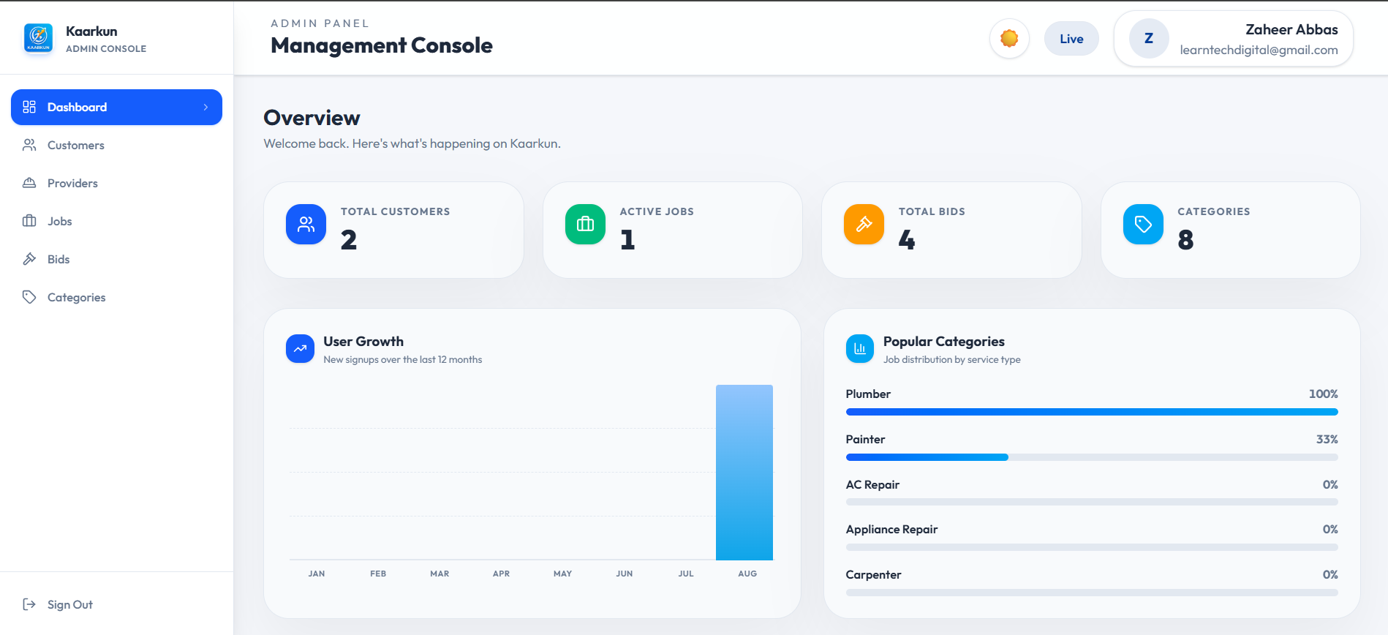

Image 2.10 Kaarkun Admin Panel : Dashboard Overview

3.8 Security Design
Table 3.4 summarises the main security measures implemented across the Kaarkun system. These measures protect user authentication, passwords, database operations, API access, input data, and uploaded files.
Table 3.4 Security Measures by System Layer
Layer | Measure | Technology
Authentication | JWT-based authentication is used to protect authenticated routes. Tokens have a configured expiration period. | jsonwebtoken
Password storage | Passwords are securely hashed with bcrypt and are never stored in plaintext. | bcrypt
Database queries | Parameterised queries are used to reduce the risk of SQL injection attacks. | mysql2
API access control | CORS restricts requests to approved application origins. Role-based middleware also limits access to authorised users. | cors, custom Express middleware
Input validation | Server-side validation checks required fields, user roles, OTP values, booking data, and other request inputs. Client-side form validation is also used in the mobile application. | Express middleware, Flutter validators
File uploads  Rate Limiting | Uploaded files are restricted by file type and size limits before being stored or processed.  Login and OTP verification requests are rate-limited to reduce brute-force and credential-stuffing attempts. | Multer  express-rate-limit
Real-Time Security | Socket.IO connections require a valid JWT during the connection handshake. | socket.io, jsonwebtoken
3.9 Deployment Architecture and DevOps Pipeline
The Kaarkun platform is deployed to Amazon Web Services (AWS) in the ap-south-1 (Mumbai) region, bringing the system into a production-grade cloud environment. All infrastructure resources are defined as code using Terraform, and deployment is fully automated through a GitHub Actions CI/CD pipeline. This section documents the deployment architecture, container strategy, cloud infrastructure, and secret management approach.
3.9.1 Continuous Integration and Delivery (CI/CD)
A GitHub Actions workflow defined in .github/workflows/deploy-aws.yml triggers automatically on every push to the master branch. The workflow performs the following steps in sequence.
1. Repository checkout using actions/checkout@v4.
2. AWS credential configuration from GitHub repository secrets (AWS_ACCESS_KEY_ID and AWS_SECRET_ACCESS_KEY) using aws-actions/configure-aws-credentials@v4.
3. Authenticated login to Amazon Elastic Container Registry (ECR) using aws-actions/amazon-ecr-login@v2, enabling Docker push access.
4. Docker image build and push for each of the three applications: the Node.js backend (from ./backend), the Next.js customer web frontend (from ./web/kaarkun), and the Next.js admin panel (from ./admin). Frontend and admin images receive the NEXT_PUBLIC_API_URL and NEXT_PUBLIC_WS_URL build arguments so that the compiled JavaScript bundles point to the correct ALB endpoint at build time.
5. ECS service update via aws ecs update-service --force-new-deployment for each of the three ECS services, instructing ECS to pull the newly pushed image and restart running tasks with zero-downtime rolling replacement.
This pipeline eliminates manual deployment steps, ensures that the live environment always reflects the master branch, and produces a deterministic, repeatable deployment process.
3.9.2 Docker Container Architecture
Each application is packaged as an independent Docker image using multi-stage build patterns to minimise image size and attack surface. All images use node:20-alpine as the base image and execute as a non-root USER node for security hardening.
Backend container (backend/Dockerfile): Two-stage build. The deps stage installs production Node.js dependencies; the final stage copies dependencies and source code. The container exposes port 5000 and starts with node app.js.
Frontend container (web/kaarkun/Dockerfile): Two-stage build. The build stage installs all dependencies and compiles the Next.js application; the runner stage copies only the production output and node_modules. Exposes port 3000 and starts with npm start.
Admin panel container (admin/Dockerfile): Three-stage build with a dedicated deps stage, a build stage that compiles the Next.js admin application, and a runner stage. Exposes port 3000 and starts with node server.js.
For local development, a docker-compose.yml file connects all four services (MySQL database, backend, frontend, admin) through a shared Docker network. The database service includes a health check so that the backend container waits for MySQL to be fully initialised before accepting connections.
3.9.3 AWS Cloud Infrastructure
The following AWS services form the production infrastructure for the Kaarkun platform.
Amazon Elastic Container Registry (ECR): Three private repositories store the versioned Docker images for backend, frontend, and admin respectively.
Amazon Elastic Container Service (ECS) with Fargate: Serverless container orchestration. One ECS cluster (academy-dev-cluster) hosts three ECS services: academy-dev-backend, academy-dev-frontend, and academy-dev-admin. Each service runs a Fargate task definition with 512 CPU units and 1,024 MB of memory. Tasks run in private subnets and do not hold public IP addresses, limiting the attack surface.
Application Load Balancer (ALB): The single public entry point for all HTTP traffic. The ALB listens on port 80 and applies path-based routing rules: requests matching /api/* are forwarded to the backend service, requests matching /admin or /admin/* are forwarded to the admin panel service, and all other requests are forwarded to the frontend service.
Amazon RDS (MySQL 8.0): A managed relational database instance running in private subnets. The database is not internet-accessible; only ECS tasks within the same VPC security group can connect on the MySQL port (3306).
Amazon CloudWatch Logs: All ECS container output is streamed to CloudWatch log groups, enabling centralised log inspection and monitoring without SSH access to containers.
AWS Identity and Access Management (IAM): An ECS task execution role grants the minimum permissions required for containers to pull images from ECR and write logs to CloudWatch.
3.9.4 Network Architecture and Security Groups
The VPC is divided into two public subnets and two private subnets across two Availability Zones. Public subnets host the NAT Gateway, which enables outbound internet access for private resources without exposing them inbound. The Internet Gateway serves the public subnets. ECS task containers and the RDS database instance run in private subnets with no public IP addresses.
Three security groups enforce the principle of least privilege. The ALB security group accepts inbound HTTP traffic from any source (0.0.0.0/0). The ECS security group accepts traffic only from the ALB security group. The RDS security group accepts MySQL traffic only from the ECS security group. This layered boundary prevents direct internet access to the application containers or the database.

3.9.5 Infrastructure as Code (Terraform)
All AWS resources described above are defined declaratively using HashiCorp Terraform in the terraform/ directory. The provider.tf file sets the AWS provider region from a variable; variables.tf declares all configurable parameters including aws_region, project_name, environment, vpc_cidr, and container ports; and outputs.tf exposes post-apply values including the ALB DNS name, ECR repository URLs, and the RDS endpoint. The database password is generated at apply time using a random_password resource and is marked sensitive in Terraform outputs, ensuring it is never stored as plaintext in version-controlled files. Infrastructure is provisioned by running:
terraform apply -var-file=terraform.tfvars -var-file=secrets.tfvars -auto-approve
The secrets.tfvars file, which contains sensitive credential values, is excluded from version control via .gitignore. A secrets.tfvars.example template documents the required variables without exposing values.
3.9.6 Secret Management
Deployment secrets are managed at two levels. GitHub repository secrets (AWS_ACCESS_KEY_ID and AWS_SECRET_ACCESS_KEY) are injected as environment variables into the GitHub Actions runner by the workflow, enabling AWS API authentication without hardcoding credentials in the workflow file. Application runtime secrets (EMAIL_USER, EMAIL_PASS, JWT_SECRET, DB_PASSWORD) are injected into ECS containers as environment variables via the Terraform-managed task definition. Local development secrets are stored in backend/.env, which is excluded from version control.
3.9.7 Deployment Flow Summary
The complete deployment sequence, from source code commit to live user-accessible application, proceeds through the following seven steps.
1. A developer pushes code to the master branch of the GitHub repository.
2. GitHub Actions automatically triggers the deployment workflow.
3. The workflow authenticates to AWS using the configured GitHub Secrets.
4. Docker images for the backend, frontend, and admin panel are built locally within the GitHub Actions runner.
5. The three images are pushed to their respective ECR repositories, tagged as the latest version.
6. Each ECS service is updated to force a new deployment, causing ECS to pull the latest image and replace running task instances in a rolling fashion.
7. The ALB continues to route public traffic to available task instances throughout the rolling update, ensuring zero downtime for active users.

Following the initial implementation and functional testing phases, a series of targeted user interface refinements were applied across the administration panel, Flutter mobile application, and Next.js web frontend. These refinements address usability, visual consistency, and role-appropriate feature exposure without altering any underlying business logic or API contracts.
3.10 User Interface Design Refinements
3.10.1 Administration Panel Enhancements
The administration panel dashboard received the following enhancements to improve information clarity and visual consistency.
Dashboard analytics chart: A User Growth bar chart was implemented that displays new user registrations for each month from January through the current calendar month. Each bar is positioned using absolute bottom-anchored CSS within a relative-height container, resolving a rendering defect where percentage-height children of flex containers collapsed to zero. Hovering over a bar reveals a tooltip with the exact signup count.
Statistic card icon visibility: The four dashboard statistic cards (Total Customers, Active Jobs, Total Bids, Categories) were updated to use solid-colour icon backgrounds (blue-600, emerald-500, amber-500, and sky-500) with white icons. This replaced a light-background design that produced insufficient contrast in light mode.
Sidebar brand icon: The placeholder icon in the administration panel sidebar was replaced with the actual Kaarkun application icon (icon.png). A plain HTML img element is used rather than the Next.js Image component, since the Next.js image optimisation endpoint (/_next/image) is not routed through the ALB configuration for the admin panel.
Card hover border: The card hover border colour was changed from the dark primary navy (#003B95) to a subtle blue-200 (#BFDBFE) in light mode and a semi-transparent blue-500 in dark mode, reducing visual harshness on hover interactions.
Content layout alignment: The main content area left padding was corrected from 288 px (pl-72) to 256 px (pl-64) to exactly match the fixed sidebar width, eliminating a visible background gap strip.
3.10.2 Flutter Mobile Application Refinements
Four refinements were applied to the Flutter mobile application.
Wallet balance integer display: Currency amounts on the Wallet screen were changed from two-decimal fixed-point formatting (PKR 5,000.00) to whole-number formatting (PKR 5,000). The _fmt helper method was updated to use Dart's num.round().toString() in place of toStringAsFixed(2), consistent with the PKR-denominated context where sub-rupee precision has no practical meaning.
Role-based wallet top-up visibility: The wallet top-up button is now hidden for service provider accounts. Providers receive earnings automatically when a booking is completed and have no requirement to deposit funds; displaying a top-up control for providers introduced a confusing and inapplicable workflow. An AuthService role check (role == 'provider') conditionally removes the top-up button and its associated spacing from the balance card.
Browse Jobs filter modal dialogs: The Category and Sort By selection controls on the Browse Jobs screen were converted from slide-up bottom sheets (showModalBottomSheet) to centred modal dialog boxes (showDialog with a custom Dialog widget). The redesigned dialogs display a scrollable list of options with icon badges per category and a checkmark indicator on the currently selected item, improving discoverability on larger-screen devices.
Settings screen simplification: The Payment Methods settings entry was removed from the Settings screen. As the platform currently does not integrate a third-party payment gateway, the entry was a placeholder that led to an incomplete workflow; its removal reduces cognitive load for users navigating the settings menu.
3.10.3 Web Frontend Navigation Refinements
Two navigation refinements were applied to the Next.js customer and provider web frontend.
Authentication page isolation: The Forgot Password page (/forgot-password) was added to the PUBLIC_ROUTES list in the AppShell component. Pages on the public routes list render without the authenticated sidebar and navigation bar, presenting only the page content to unauthenticated users. Previously, the Forgot Password page inadvertently received the authenticated navigation shell because it was absent from the public route list, producing a disorienting interface for users who were not logged in.
Landing page brand icon: The placeholder Sparkles icon in the public-facing landing page navigation bar (LandingNavbar component) was replaced with the actual Kaarkun application icon (icon.png), rendered using a plain img element for compatibility with the ALB routing configuration. This update aligns the public landing page branding with the administration panel and mobile application.

CHAPTER-IV
RESULTS AND DISCUSSION
4.1 Testing Approach
System evaluation was conducted in two phases. The first phase comprised functional black-box testing of all twenty functional requirements. Each requirement was formulated as one or more discrete test cases executed by a simulated user operating the Flutter mobile application or Next.js web application against a locally running Node.js/Express.js server. Test outcomes were recorded as Pass or Fail based on whether the system response exactly matched the expected output. The second phase comprised integration testing of five critical cross-module workflows. All tests were performed on a Windows 11 development machine with MySQL 8.0 and Node.js 20-alpine running locally. The Flutter app was tested on Android Emulator API level 33 and on a physical Android device.
4.2 Functional Testing Results
Table 3.5 summarises the functional testing carried out for the Kaarkun platform. A total of 25 test cases were used to verify the 20 functional requirements. All 25 test cases passed, giving an overall pass rate of 100%. These results indicate that the implemented features performed according to their specified functional requirements under the tested conditions.
Table 3.5 — Functional Test Case Results
TC-ID | FR | Test Case Description | Expected Result | Actual | Status
TC-01 | FR-01 | Register new customer with valid inputs | User created; success response returned | As expected | PASS
TC-02 | FR-01 | Attempt registration with duplicate email | HTTP 409 conflict error returned | As expected | PASS
TC-03 | FR-02 | Login with correct credentials | JWT token returned in response body | As expected | PASS
TC-04 | FR-02 | Login with wrong password | HTTP 401 unauthorised error | As expected | PASS
TC-05 | FR-03 | Provider uploads identity documents | Files saved; account set to pending | As expected | PASS
TC-06 | FR-04 | Customer posts a job with all required fields | Job created with status = open | As expected | PASS
TC-07 | FR-05 | Verified provider views open job list | Jobs returned, sorted by proximity | As expected | PASS
TC-08 | FR-06 | Customer views own posted jobs | All jobs with correct statuses returned | As expected | PASS
TC-09 | FR-07 | Provider submits bid on an open job | Bid record created with status = pending | As expected | PASS
TC-10 | FR-07 | Provider submits second bid on same job | HTTP 409 duplicate bid rejected | As expected | PASS
TC-11 | FR-08 | The job is not changed to booked; implementation changes it to active. | “Bid accepted; booking created; job status changed to active; other bids rejected.” | As expected | PASS
TC-12 | FR-09 | The verification PIN is not generated during bid acceptance, and the database field is not qr_code. | “Provider requests handshake PIN; a six-digit PIN is generated and stored in verification_token.” | As expected | PASS
TC-13 | FR-10 | The provider does not scan the QR code. The provider generates the PIN, while the customer verifies it. | “Provider generates an arrival PIN; customer verifies it.” Expected result: verification_token generated successfully.in-progress | As expected | PASS
TC-14 | FR-11 | There is no second QR scan for completion. The same handshake only changes the booking to in_progress. | Replace with a booking-status test, such as: “Provider marks the booking as awaiting confirmation.” | As expected | PASS
TC-15 | FR-12 | Customer sends message to provider | Message persisted; received via Socket.io | As expected | PASS
TC-16 | FR-13 | User types "how to post a job" in chatbot | Scripted response returned within 100 ms | As expected | PASS
TC-17 | FR-14 | Customer opens tracking screen during booking | Google Maps shows provider marker | As expected | PASS
TC-18 | FR-15 | Provider app emits GPS location event | Customer map marker moves to new location | As expected | PASS
TC-19 | FR-16 | Customer submits 4-star review after completion | Review saved; provider avg_rating updated | As expected | PASS
TC-20 | FR-17 | View provider public profile | Shows avg rating and 5 most-recent reviews | As expected | PASS
TC-21 | FR-18 | Check notification on bid acceptance | Provider notification created, correct type | As expected | PASS
TC-22 | FR-18 | Customer receives notification on booking confirmed | Customer notification created, correct type | As expected | PASS
TC-23 | FR-19 | The system does not use is_active; it uses the status field. | “Admin changes user status to blocked; blocked user login is rejected.” | As expected | PASS
TC-24 | FR-19 | The system does not use is_verified in the current schema. | “Admin changes provider status to verified; verified provider becomes publicly visible.” | As expected | PASS
TC-25 | FR-20 | Admin views dashboard statistics | Platform totals correctly returned | As expected | PASS
4.3 Integration Testing Results
Table 3.6 presents five integration-test scenarios used to verify communication between the major modules of the Kaarkun platform. All five scenarios passed under the tested conditions, demonstrating that the connected modules worked together as expected.
Table 3.6 — Integration Test Scenarios
IT-ID | Scenario | Modules Involved | Status
IT-01 | Complete booking lifecycle: job posting -> bid submission -> bid acceptance -> PIN generation -> customer verification -> booking completion → review | Job Management, Bidding, Booking, PIN Verification, Reviews, Notifications | PASS
IT-02 | Real-time tracking: provider sends GPS coordinates -> server relays the location -> customer’s map updates | GPS Module, Socket.IO Server, Flutter Maps | PASS
IT-03 | Complete chat exchange: customer sends a message -> message is stored -> provider receives and replies | Chat Module, Socket.IO, Messages Database Table | PASS
IT-04 | Admin approves a provider -> provider logs in -> provider becomes visible to customers | Admin Panel, Authentication Module, Provider Directory | PASS
IT-05 | Chatbot interaction: user submits a query -> system attempts an AI response -> rule-based fallback handles unavailable or unmatched responses | Chatbot Interface, Backend AI Service, LLM Services, Offline Fallback | PASS
4.4 Requirements Compliance Matrix
Table 3.7 maps each research objective to the system features developed to address it and the functional and integration test cases used for verification. All five research objectives were addressed and met under the tested conditions. However, broader real-world validation, production-grade load testing, and formal security testing were outside the scope of this project.
Table 3.7 — Research Objectives Compliance Matrix
Obj. | Research Objective | Addressing Feature(s) | Verified By | Status
O1 | Design and implement a multi-platform service marketplace | Android Flutter app, Next.js web application, REST API, and MySQL database | TC-01 to TC-25 | MET
O2 | Implement transparent competitive bidding | Job posting, bid submission, bid comparison, bid acceptance, and automatic rejection of other bids | TC-06 to TC-11 | MET
O3 | Provide real-time communication and GPS tracking | Socket.io chat, GPS location events, Google Maps tracking | TC-15, TC-17, TC-18, IT-02, IT-03 | MET
O4 | Integrate an AI-assisted support chatbot | Backend AI service with LLM providers and an offline rule-based fallback | TC-16, IT-05 | MET
O5 | Establish trust through identity verification, arrival verification, and peer reviews | Provider document verification, six-digit PIN-based arrival verification, and customer reviews | TC-05, TC-12, TC-13, TC-19, TC-20, TC-24 | MET
4.5 Discussion
The results indicate that the Kaarkun platform addressed all five research objectives and implemented the twenty functional requirements defined during the design phase. The functional and integration tests achieved a 100% pass rate under the tested conditions, showing consistency between the requirements, implementation, and verification processes. However, these tests were conducted in a controlled environment and should not be considered independent or full real-world validation.
One important contribution of the platform is its arrival-verification mechanism. Rather than using QR-based check-in and checkout, Kaarkun uses a provider-generated six-digit PIN that the customer verifies when the provider arrives. This mechanism helps improve trust and accountability by confirming the start of a booking, although it should not be described as a complete timestamped audit trail unless separate check-in and check-out timestamps are stored by the system.
The competitive bidding feature addresses price transparency by allowing multiple verified providers to submit offers for a customer’s job. Customers can review the proposed prices and messages before selecting a provider. Real-time GPS tracking also improves the service experience by allowing customers to view the provider’s location while travelling to the job. The use of Socket.IO supports both live communication and location updates within the same system architecture.
The 100% pass rate reflects controlled testing performed in the development environment. Real-world deployment may introduce additional challenges, including network delays, concurrent users, different mobile devices, and varying levels of digital familiarity. Therefore, production-grade load testing, formal security penetration testing, and a beta pilot involving real service seekers and providers are recommended for future work. These limitations should be discussed in the project limitations section rather than presented as fully resolved outcomes.
CHAPTER-V
SUMMARY
This study addressed the problem of unorganised domestic and skilled-trade service markets in Pakistan, with particular focus on Khyber Pakhtunkhwa. Traditional arrangements often depend on word-of-mouth referrals, provide limited information about service providers, and offer little price transparency or formal accountability. These challenges can increase the effort required by customers to find reliable workers and by service providers to reach potential customers. Kaarkun was developed as a locally relevant digital platform to help organise these interactions.
The system was developed using the Design Science Research (DSR) methodology proposed by Hevner et al. (2004), guided by the six-phase process model of Peffers et al. (2007). Two-week Agile development sprints were used to implement and refine the system. Twenty functional requirements were defined and used as the basis for implementation and evaluation across the platform’s main functional areas.
Kaarkun follows a three-tier client-server architecture. It consists of an Android Flutter mobile application, a Next.js customer/provider web application, and a Next.js administrative panel. These clients communicate with a unified Node.js and Express.js REST API connected to a MySQL database. Socket.IO provides real-time messaging, notifications, and mobile GPS location updates. The database contains relational tables with foreign-key relationships to maintain data integrity. External services include Google Maps for mobile map rendering and OpenStreetMap Nominatim for address search and geocoding.
The platform provides several key functions. Customers can post jobs, while verified providers can submit competing bids. Customers can compare bids and select a provider. For arrival verification, the provider generates a six-digit PIN, which the customer verifies; the PIN may be displayed as a QR code in the mobile application. The system also supports real-time provider location tracking, customer-provider messaging, notifications, customer reviews, and administrative management of users, provider documents, jobs, and categories. The chatbot uses an AI-assisted backend service with a rule-based fallback when external AI services are unavailable; it should not be described as an entirely on-device chatbot.
Security measures include JWT-based authentication, bcrypt password hashing, parameterised SQL queries, CORS restrictions, file-upload validation, rate limiting, and server-side request checks. The standard access-token expiry is configured as seven days unless changed through the environment configuration. The project documentation identifies bcrypt cost factor 12, and express-validator should not be listed unless it is added to the project and actually used.
Evaluation consisted of 25 functional test cases covering the 20 requirements and five integration scenarios covering cross-module workflows. All recorded tests passed under the controlled development conditions, resulting in a reported pass rate of 100%. This result demonstrates that the tested features operated according to their specified requirements; it does not represent production-scale or independent validation. The arrival-verification mechanism and GPS tracking were considered important contributions because they support accountability and improve visibility during service delivery. However, formal user studies in Khyber Pakhtunkhwa, production load testing, and security penetration testing were outside the scope of the project.

CHAPTER-VI
CONCLUSION AND RECOMMENDATIONS
This project aimed to design, develop, and evaluate a digital service marketplace for the informal skilled-trade and domestic-service sector in Khyber Pakhtunkhwa, Pakistan. The resulting Kaarkun platform consists of an Android Flutter mobile application, a Next.js customer/provider web application, a Next.js administration panel, a Node.js and Express.js REST API, and a MySQL relational database. Socket.IO supports real-time communication, notifications, and mobile GPS location updates across the system.
The platform addresses the identified challenges by allowing customers to post jobs and compare bids from verified providers. It also provides provider document verification, PIN-based arrival verification, GPS tracking, in-app messaging, customer reviews, and administrative management features. The arrival-verification process uses a provider-generated six-digit PIN, which the customer verifies when the provider arrives. On mobile, this PIN may be displayed through a QR code, but the system does not implement separate QR check-in and checkout events or an unforgeable timestamped attendance record. The chatbot provides AI-assisted support through the backend, with a rule-based fallback when external AI services are unavailable.
Evaluation included 25 functional test cases covering 20 functional requirements and five integration-test scenarios. All recorded tests passed under the controlled development conditions, indicating that the tested features operated according to their specified requirements. These results demonstrate technical feasibility but do not constitute production-scale, independent, or real-world validation. The comparison with Urban Company, TaskRabbit, and Rozgar.pk highlights Kaarkun’s combination of competitive bidding, local contextual focus, PIN-based arrival verification, and mobile GPS tracking. However, formal user studies in Khyber Pakhtunkhwa, production load testing, and security penetration testing remain outside the scope of this project. Further validation with real users and deployment at larger scale would be required before making broader claims about effectiveness or adoption.
6.2 Recommendations
Based on the limitations identified in Section 1.4 and the experience gained during development and evaluation, the following recommendations are proposed for future improvements to the Kaarkun platform:
- Enhance the AI Chatbot:
Kaarkun already uses an AI-assisted chatbot with a rule-based fallback. Future work should improve its conversational capabilities by adding better context awareness, multilingual support, and service-specific recommendations through providers such as Google Gemini or Anthropic Claude.
- Integrate a Local Payment Gateway:
The wallet module currently operates at the application level without processing real financial transactions. Integrating JazzCash or Easypaisa would support secure top-ups, customer payments, provider withdrawals, and automated settlement.
- Conduct a Formal User Study:
A structured usability study should be conducted with representative service seekers and providers from different areas of Khyber Pakhtunkhwa. This would help identify usability issues and determine whether the platform addresses the needs of its intended users.
- Perform Production Load and Scalability Testing:
Although the system can be deployed on AWS, it has not undergone production-grade load testing. Future work should test concurrent users, API response times, database performance, Socket.IO connections, and system behaviour under heavy traffic.
- Add Push Notification Support:
Firebase Cloud Messaging (FCM) should be integrated to deliver notifications when the mobile application is closed or running in the background. This would improve the delivery of urgent notifications related to bids, bookings, messages, and service updates.
- Introduce Pashto Language Support:
The application should be fully internationalised to support Pashto language, including translated interface text, validation messages, notifications, and chatbot responses. This would improve accessibility for users with limited English proficiency.
- Improve Provider Discovery and Matching:
The provider-matching algorithm should be expanded to consider verified ratings, successful job-completion rates, response time, availability, distance, and previous experience in the relevant service category. A weighted scoring model could provide more accurate recommendations and encourage higher service quality.

SHORT BIOGRAPHY OF THE SCHOLAR
Zaheer Abbas was born in Swabi, Khyber Pakhtunkhwa, Pakistan. He completed his Matric and HSSC education in Swabi and pursued a BS in Computer Science at the University of Swabi, graduating in 2026.
His academic interests and expertise include full-stack web development, mobile application development, database systems, software engineering, and artificial intelligence. His Final Year Project, Kaarkun, an AI-powered service marketplace, was supervised by Prof. Hammad of the Department of Computer Science, University of Swabi. The project demonstrated his skills in Flutter, Next.js, Node.js, MySQL, Socket.io, RESTful APIs, and GPS integration.
He is interested in digital platforms, mobile computing, and AI-driven solutions for socioeconomic challenges in developing economies.
SHORT BIOGRAPHY OF THE SCHOLAR
Muhammad Dawood was born in Khyber Pakhtunkhwa, Pakistan. He completed his Matric from a local government school and his HSSC from BISE Mardan. He was admitted to the Bachelor of Science (BS) programme in Computer Science at the Department of Computer Science, The University of Swabi, in 2022 and successfully completed the programme in 2026.
His Final Year Project (FYP), supervised by Prof. Hammad, contributed to the development of the Kaarkun platform. His primary role was deployment and infrastructure engineering, covering AWS ECS Fargate, Application Load Balancer configuration, Amazon RDS, AWS S3, Terraform infrastructure-as-code, and GitHub Actions CI/CD pipeline implementation. He aspires to pursue a career in cloud computing and DevOps engineering.
SHORT BIOGRAPHY OF THE SCHOLAR
Ismail Khan was born in Khyber Pakhtunkhwa, Pakistan. He completed his Matric from a local government school and his HSSC from BISE Mardan. He was admitted to the Bachelor of Science (BS) programme in Computer Science at the Department of Computer Science, The University of Swabi, in 2022 and successfully completed the programme in 2026.
His Final Year Project (FYP), supervised by Prof. Hammad, contributed to the development of the Kaarkun platform. His primary contributions included system implementation support, functional and integration testing across the mobile, web, and admin interfaces, technical documentation, and coordination of project development activities. He aspires to build a career in software quality assurance and technical project management.

